**NAAN MUDALVAN ASSIGNMENT**

**NAME: VIGNESH S**

**DEPARTMENT**: BE COMPUTER SCIENCE ENGINEERING

**COLLEGE**: 8151 DHANALAKSHMI SRINIVASAN INSTITUTE OF TECHNOLOGY

**NAANMUDHALVAN COURSE**: DIGITAL MARKETING

**NM ID**: 8A2F32943D5A3389C784947A1267D6CE

ASSIGNMENT 1:

Create a blog or website using Blogspot and word press. Customize the theme design and post new article with 500 words.

URL:<https://zuviccars.blogspot.com/2023/08/zuvic-details.html>

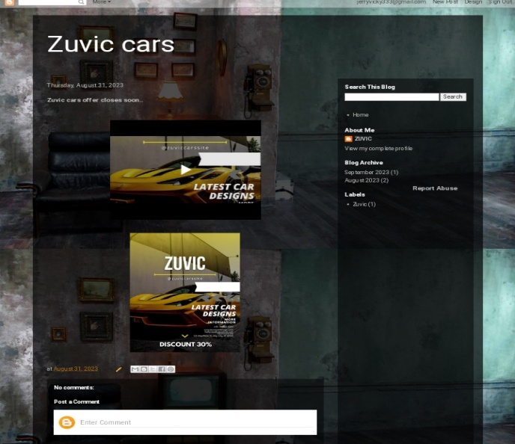

ASSIGNMENT 2:

Create a new Facebook business page and post one social media poster for your brand.

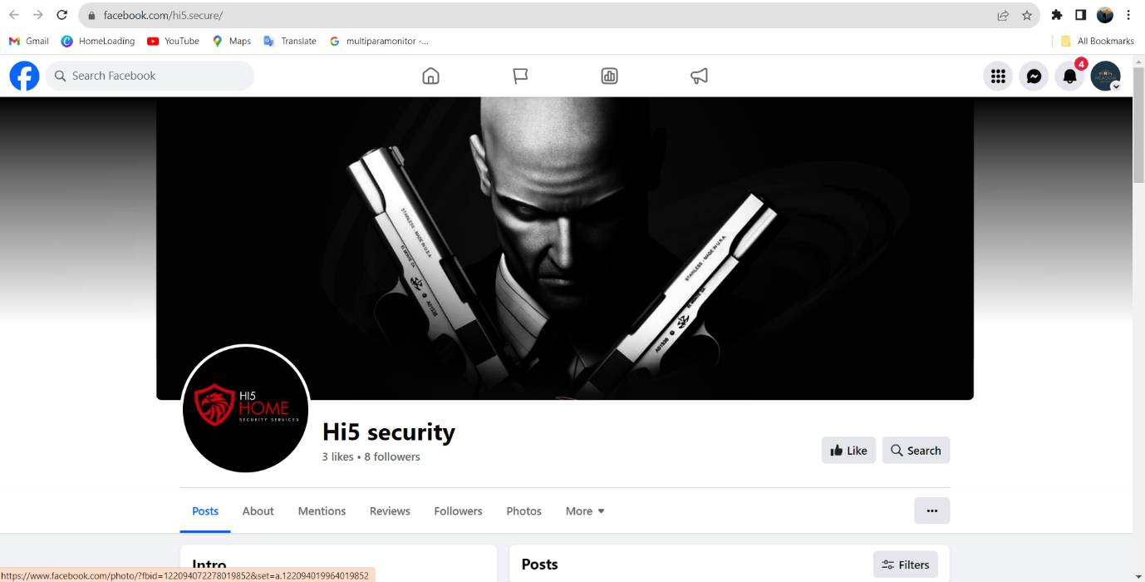URL: <https://www.facebook.com/hi5.secure/>

ASSIGNMENT 3:

Create and design a advertisement poster using Canva.

URL[: https://zuviccars.blogspot.com/2023/08/zuvic-cars-offer-closes-soon.html](:%20%20https:/zuviccars.blogspot.com/2023/08/zuvic-cars-offer-closes-soon.html)

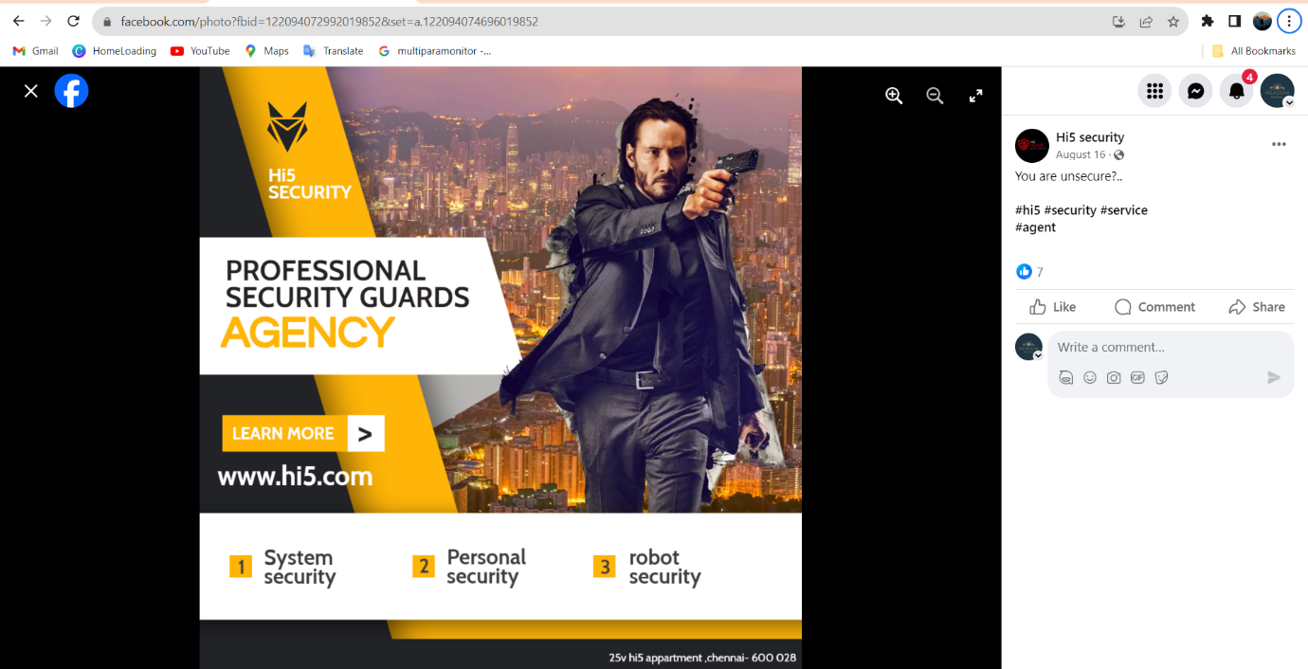

ASSIGNMENT 4:

Create an E mail newsletter design using Mailchimp or Canva tool.

URL:<https://zuviccars.blogspot.com/2023/09/zuvic-cars.html>

